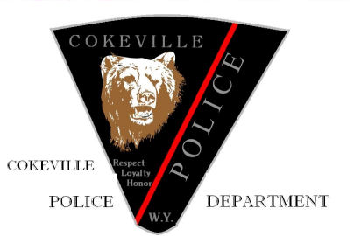
Cokeville Police Department
March 2, 2020

The Town of Cokeville Police Department is seeking qualified candidates for the position of Police Officer. This position has an annual pay range from $40,000 to $45,000 depending on experience. Lateral transfers of current Law Enforcement Officers are preferred, but not required. Lateral transfers must be current Wyoming POST certified or be certified from another state with eligibility for the Wyoming POST Challenge. The Cokeville Police Department benefits package includes; blue cross/blue shield family health insurance, vacation, holidays, sick time and participation in the Wyoming State retirement program. Cokeville Police Department offers take home vehicles and updated weapons and duty equipment. Cokeville Police Department has one working K-9 Unit at this time with hopes of expanding the program.

The Cokeville Police Department is a very community-oriented agency focusing on high visibility in the community. Cokeville is a small community with around 550 residents that mainly consist of farmers, ranchers, teachers, oil and gas industry workers and mine workers. Cokeville is a very family-oriented community. Cokeville has a High school and Elementary school located in the town limits. Cokeville is located in Lincoln County school district #2 and has great athletics programs and academic focus. Cokeville is a very rural community located on the western border of Wyoming.

Qualifications will consist of applicants being able to pass a complete background check, physical fitness assessment, a written exam, oral board, medical exam, drug screening and a psychological exam with the Cokeville Police Department. High school diploma or G.E.D. is also required. Any non-certified law enforcement applicants will be required to attend/pass Wyoming Law Enforcement Academy within one year of hiring date. Current Wyoming POST certified officers will have preference. Applications are available at the Cokeville Town Hall clerk’s office or through the Town of Cokeville website, https://www.cokeville.net . Please bring or mail your application to Cokeville Police Department, Attn: Chief Kirkland, 110 Pine Street / P.O. Box 99 Cokeville, WY 83114.

Successful applicants will be notified by mail of the testing date.
Open until filled.

The Town of Cokeville is an Equal Opportunity Employer, and we do not discriminate based on race, religion, sex, color, age, national origin or disability.

